Building API Languages

* Ruby and Python

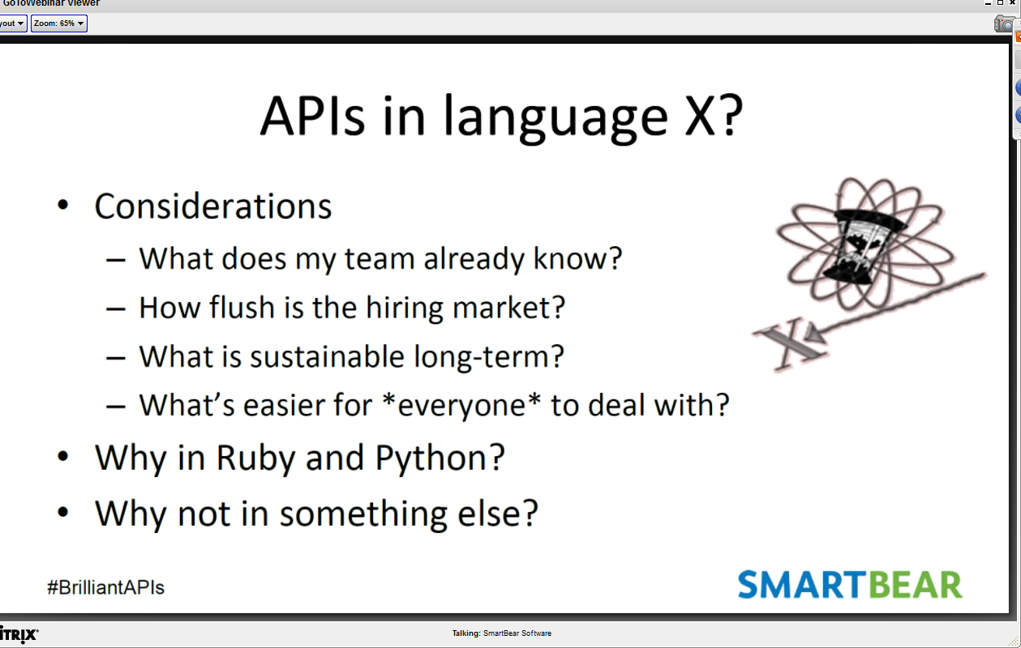

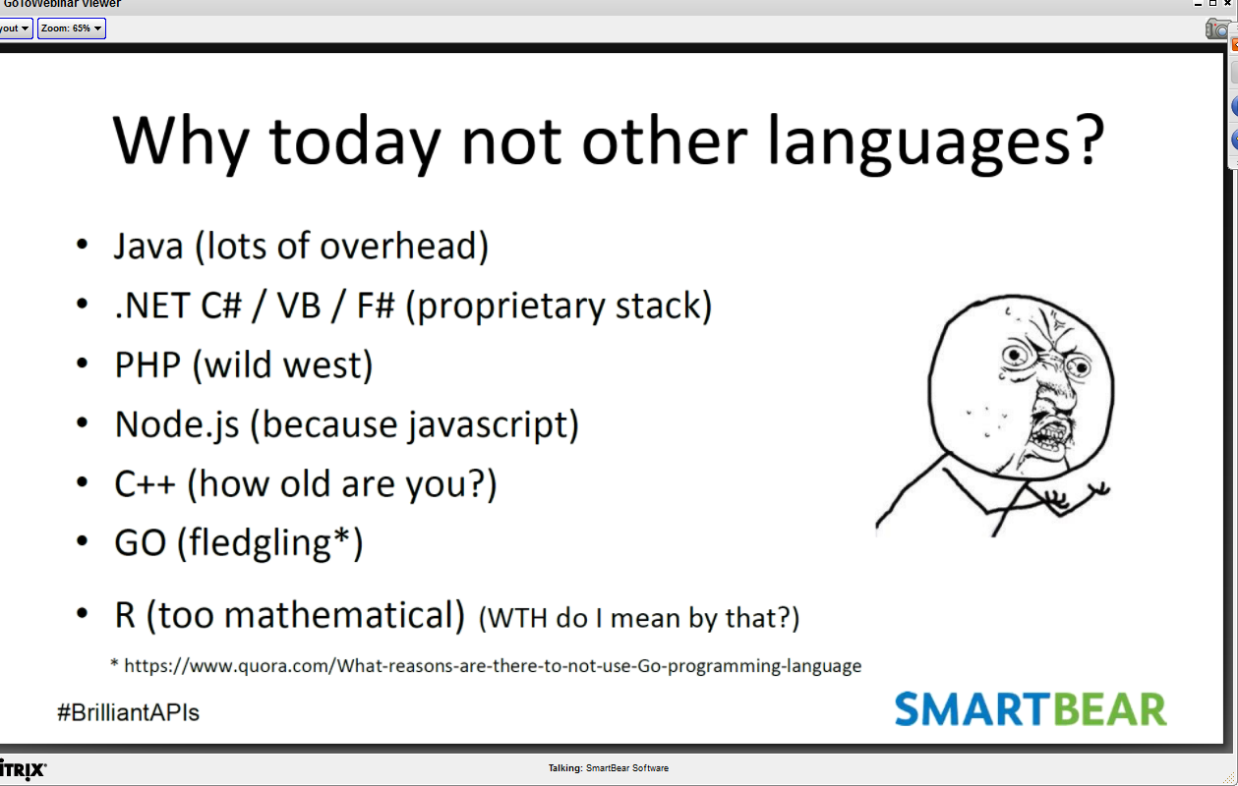

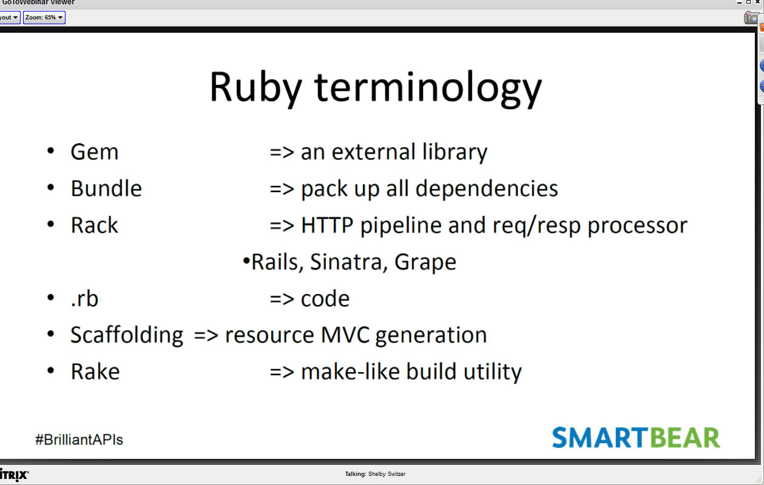

* Ruby & Rails
  + Ruby has been around for some time but was very
  + Rails: a web framework for ruby
* Caching
  + Rails provides help on caching

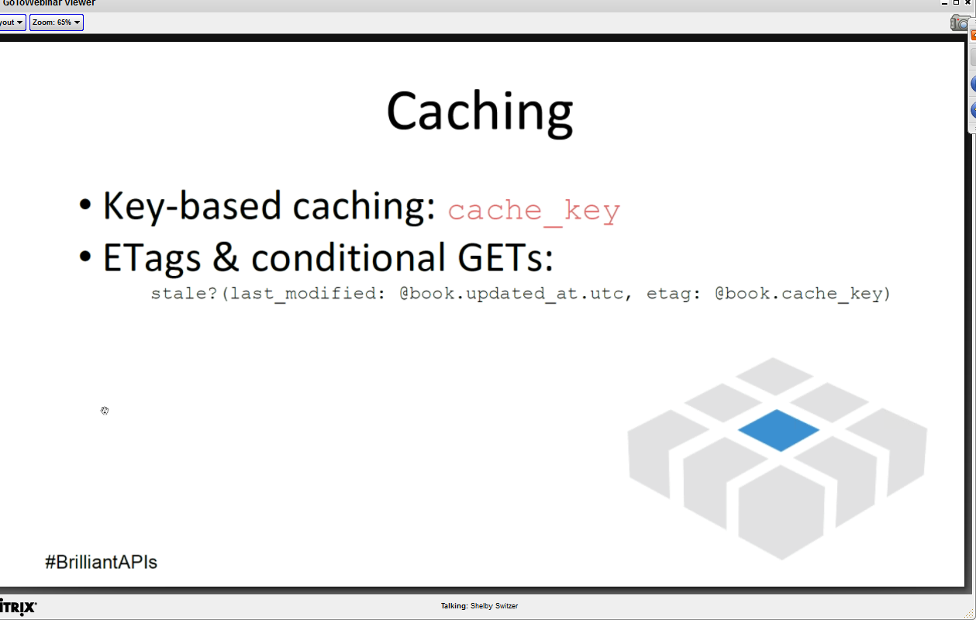

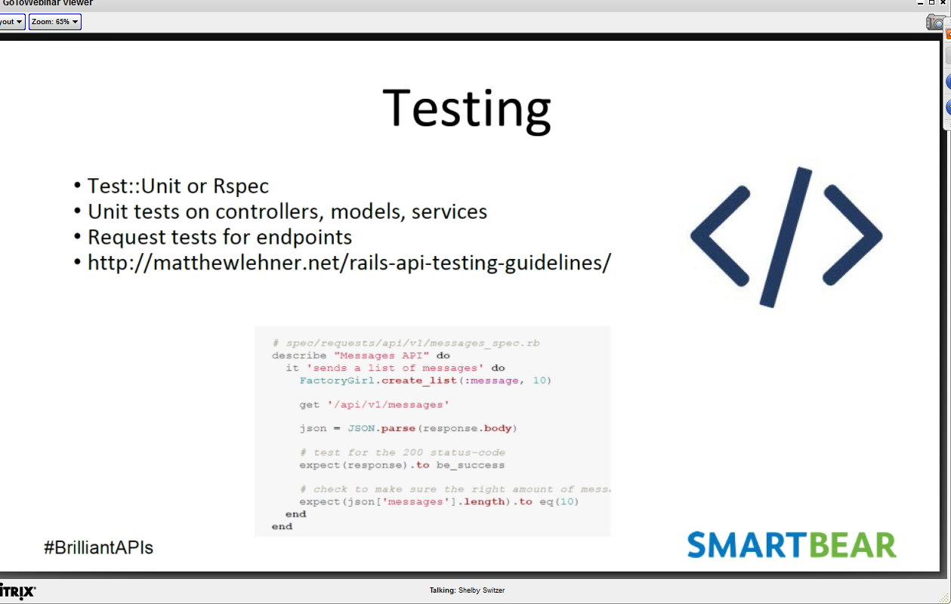

* Hypermedia
  + Rails 5 with integration with APIgem easy to put in Hypermedia
  + See gem ‘roar’
* Documentation

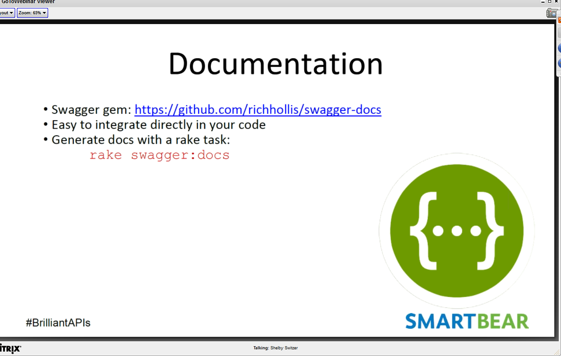

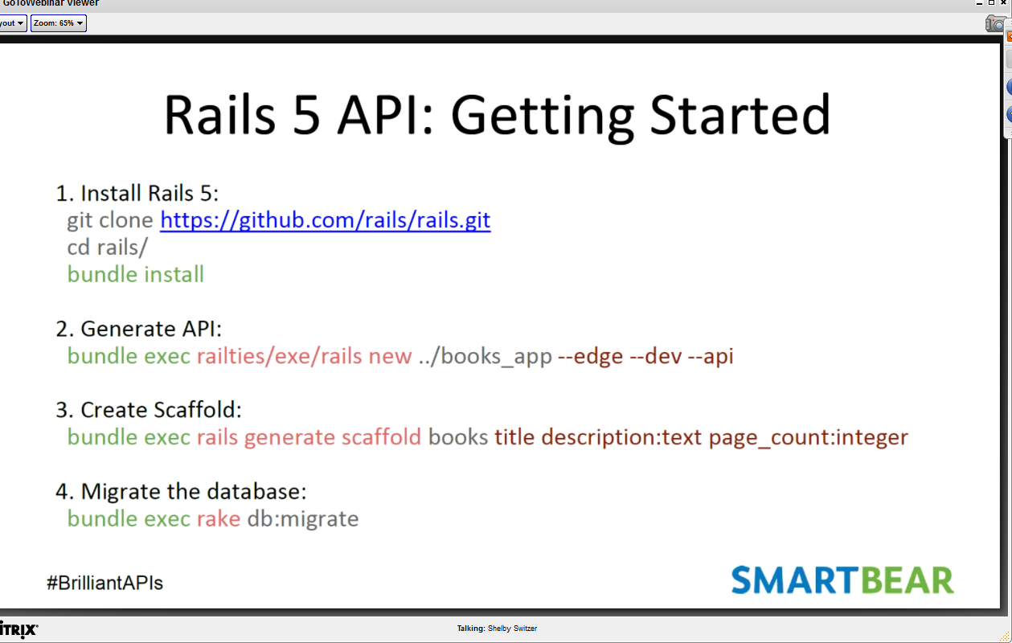

* Rails 5 hasn’t been released yet, have to clone repository
  + Note Generate API “--api" says we are only interested in API

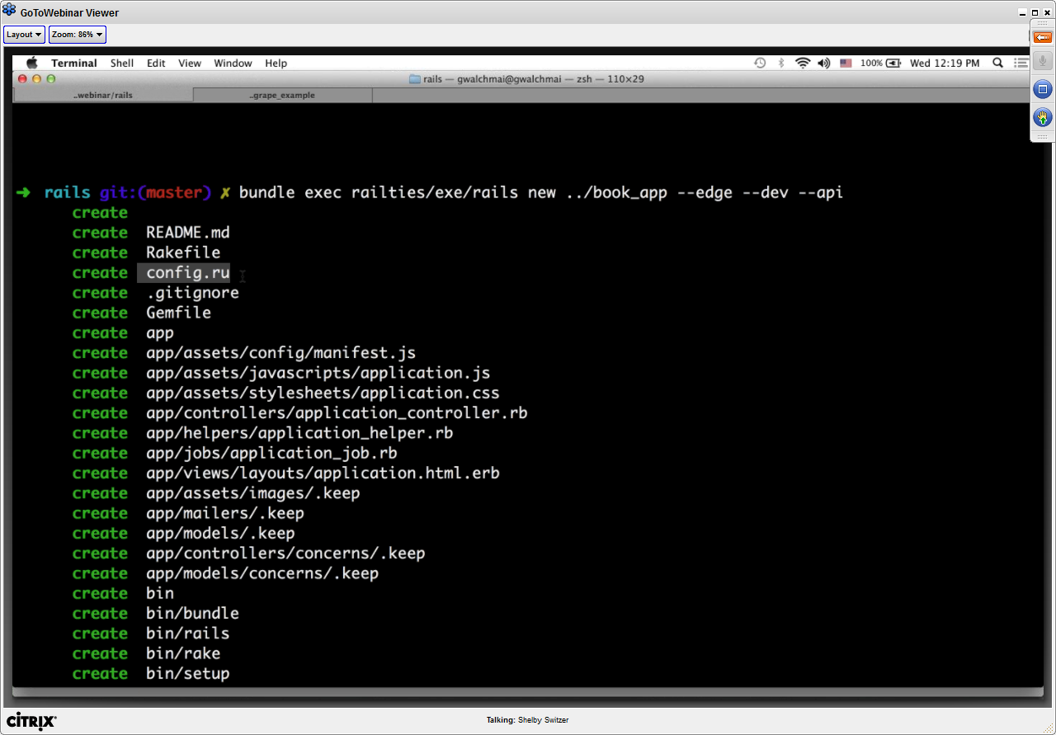

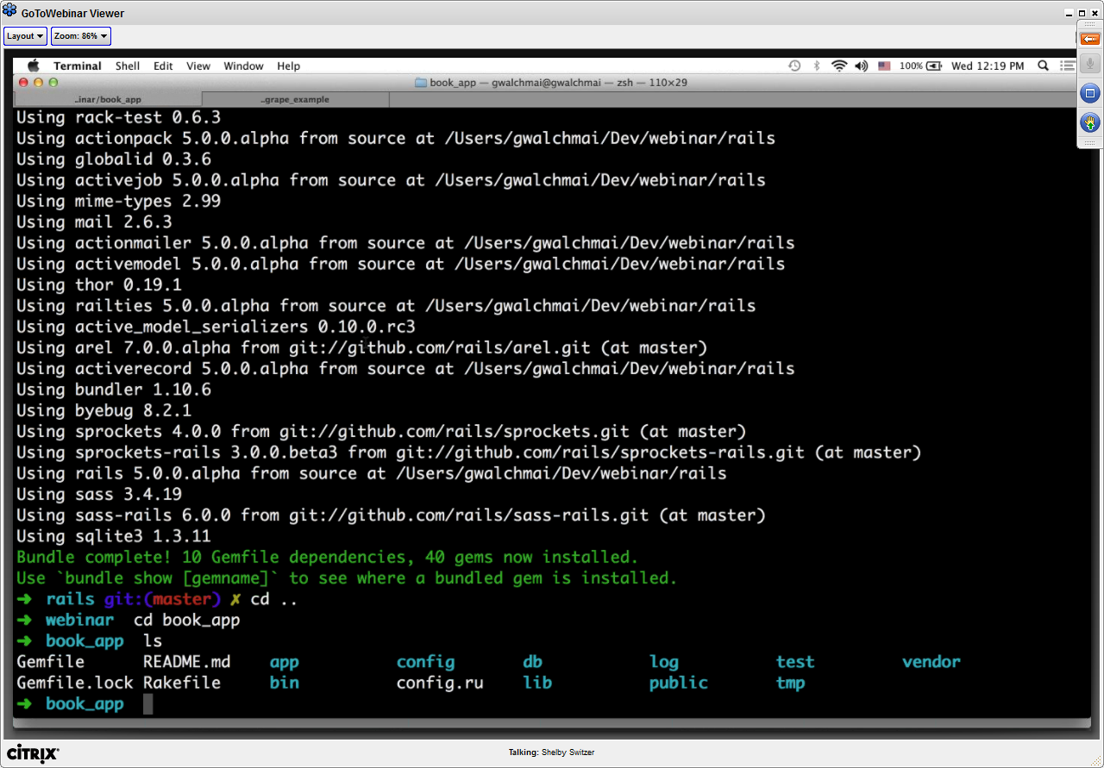

IDE is RubyMine

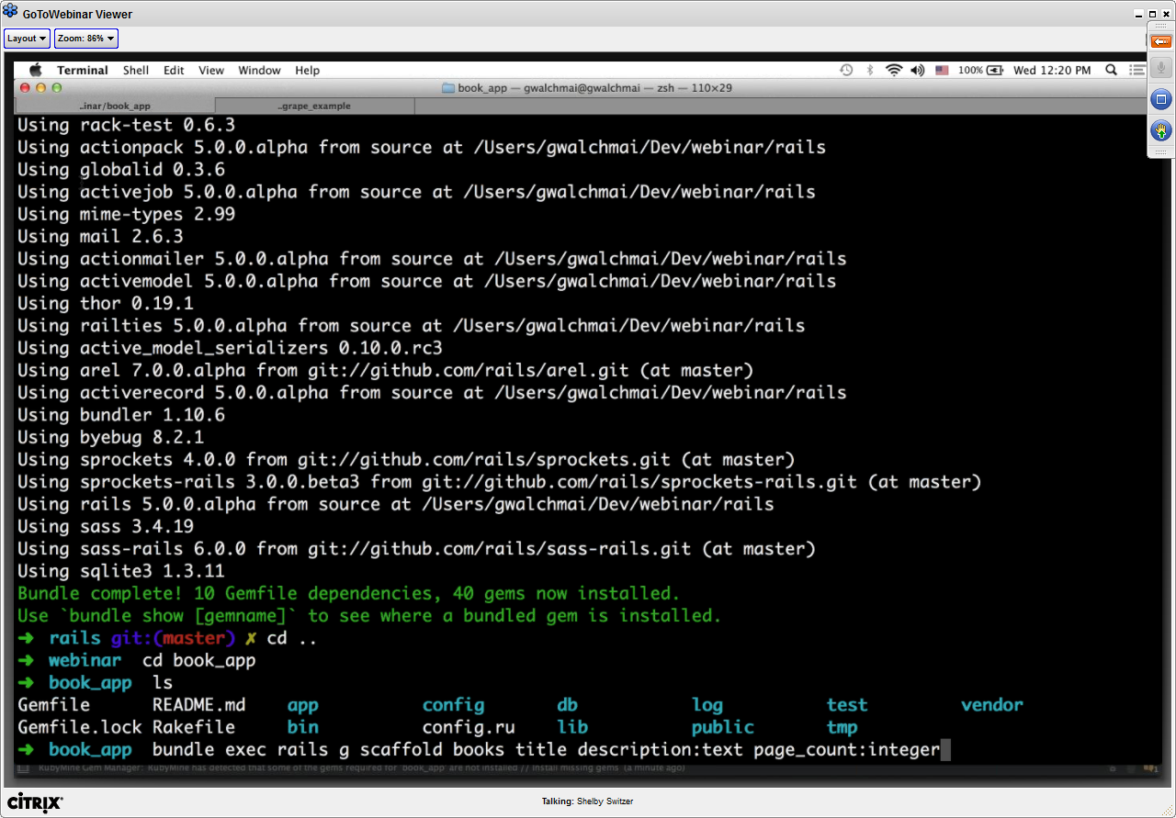

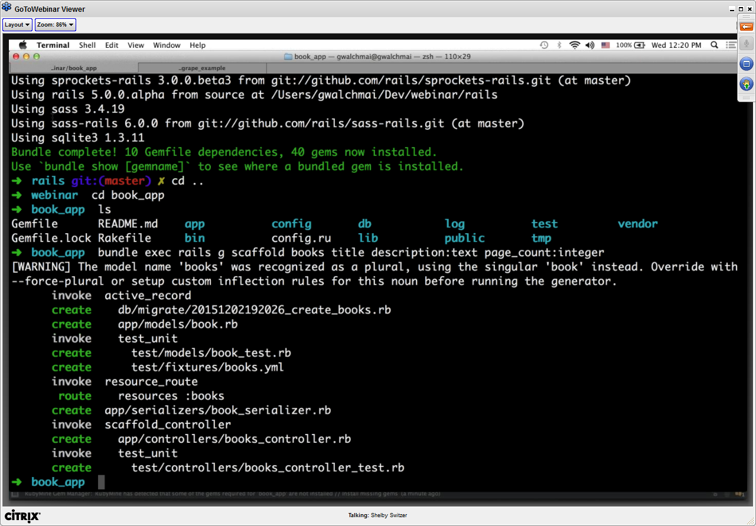

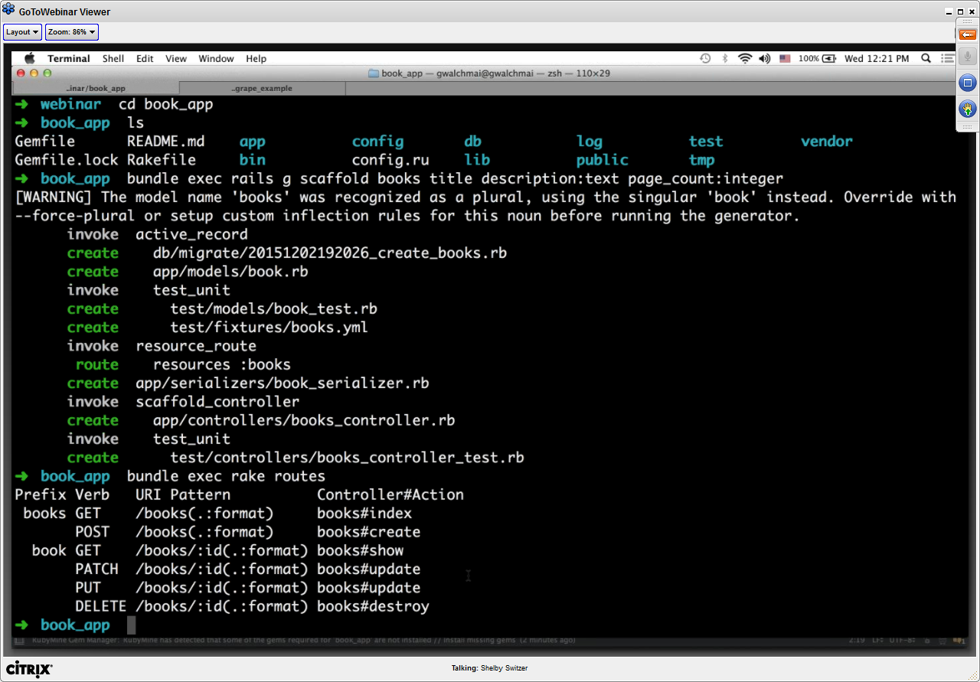

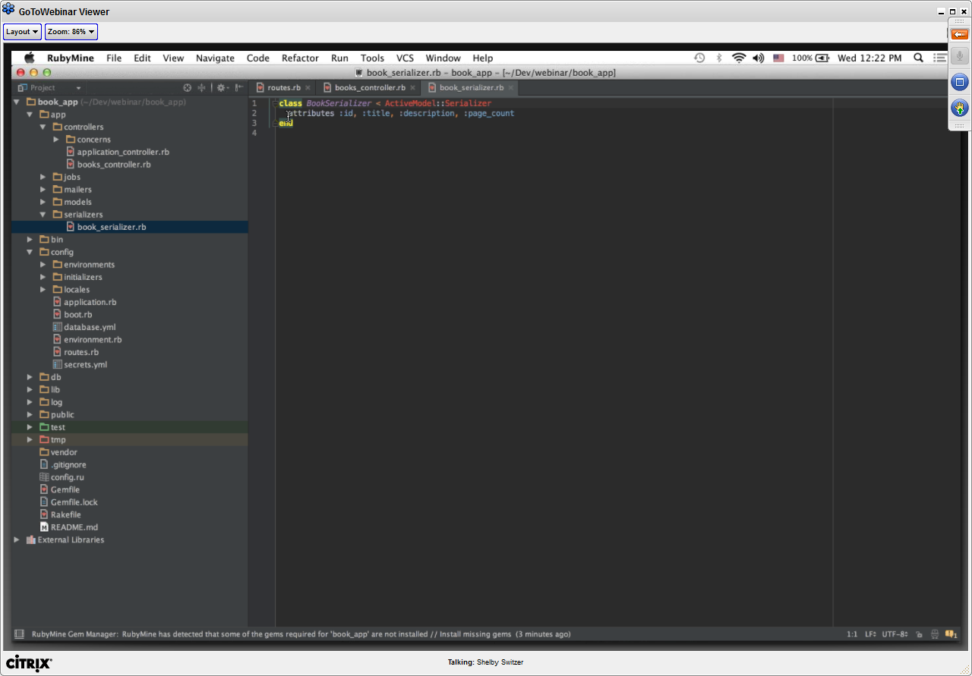

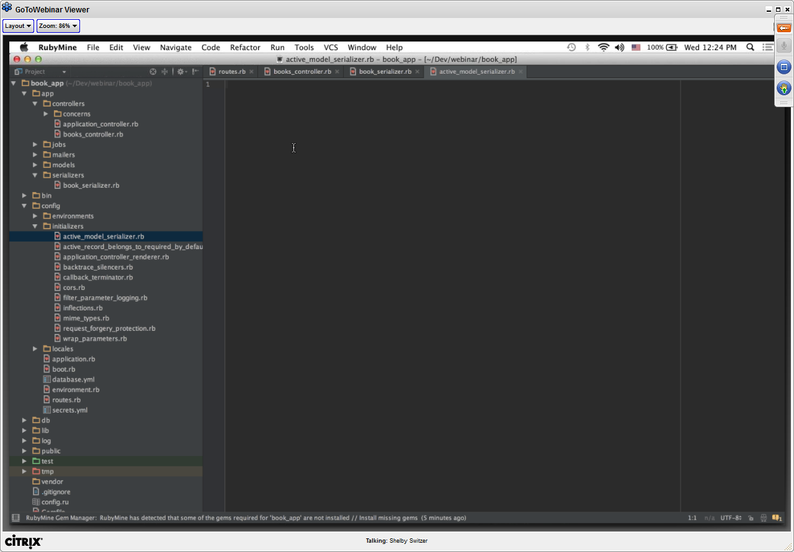

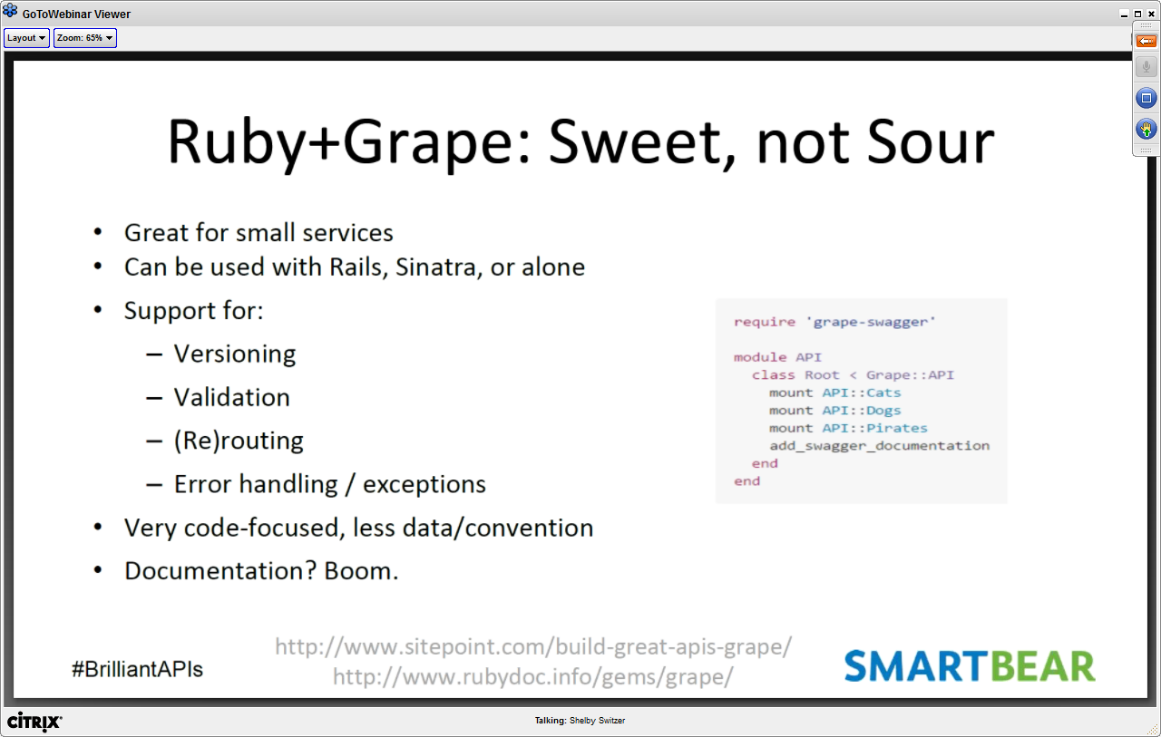

* Rails is more heavy weight than grape and hence provides more capabilities, especially around hypermedia
* Grape is much more code focused than rails

Python

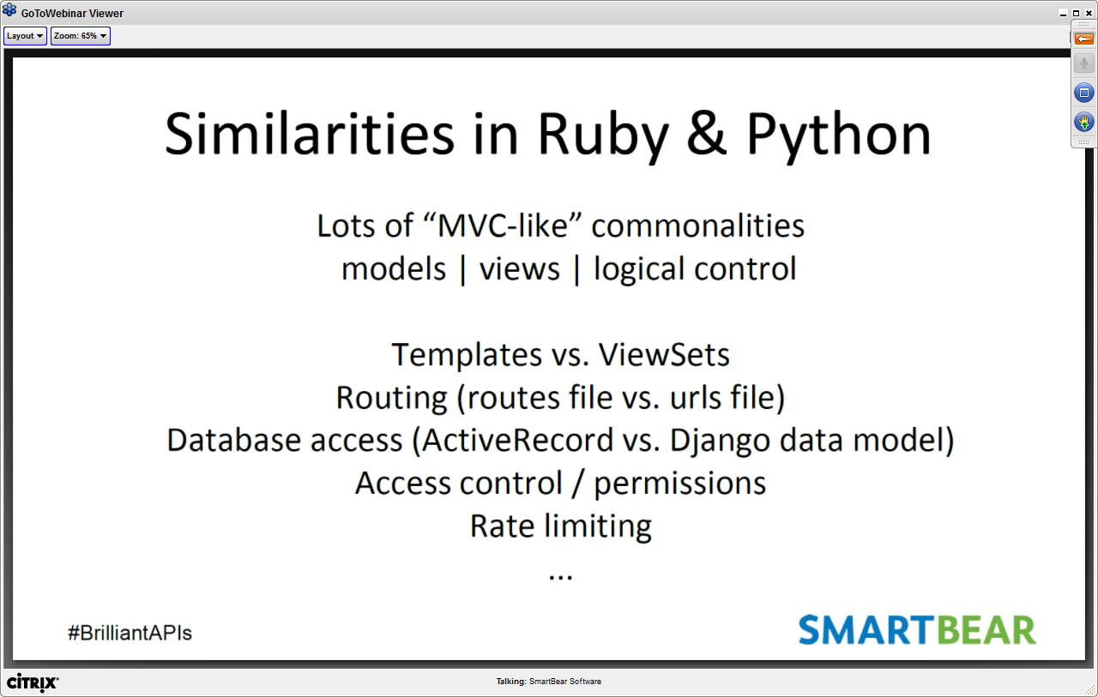

* Python: flask & Django
  + Flask: limited, but gets you there fast
  + Django: fully featured, but a bit more work

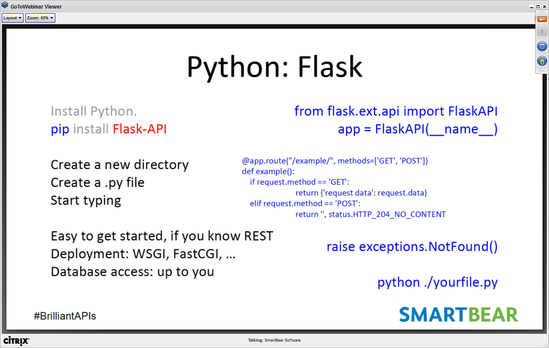

* Python IDE – PyCharm Community Eidtion 5.0.1

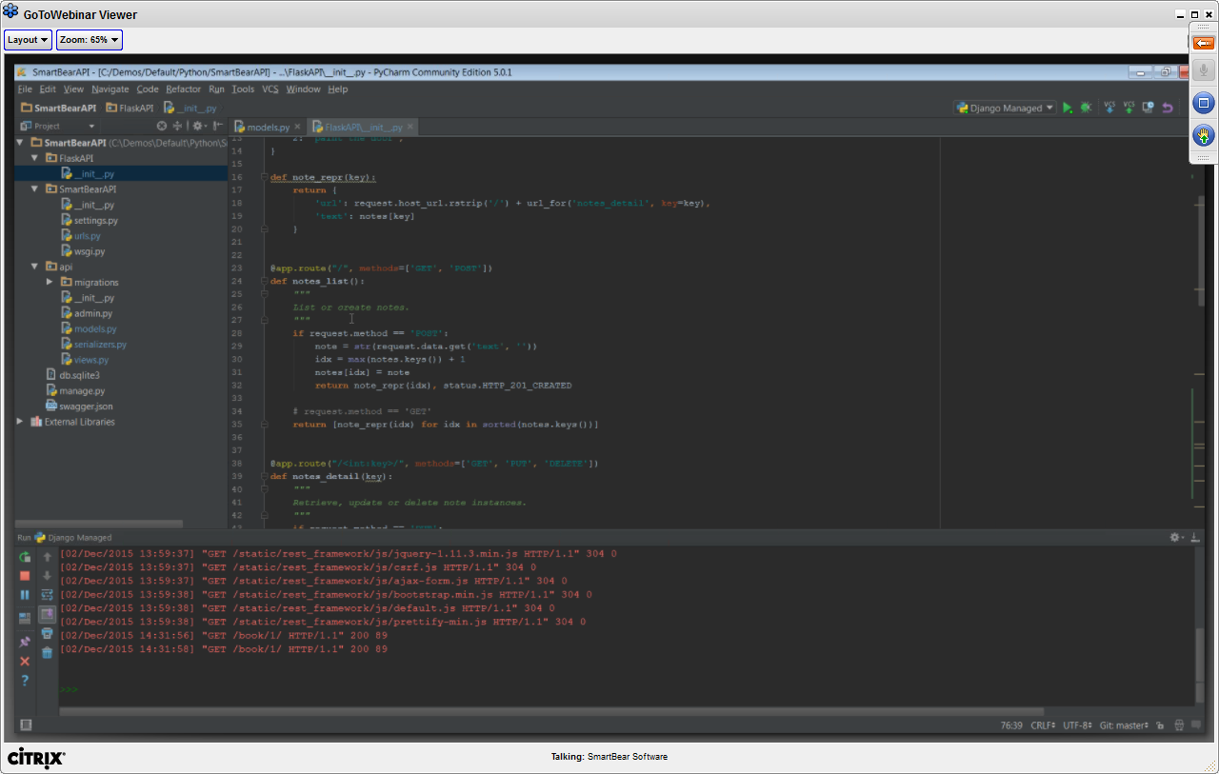

* Short coding for small APIs (not full enterprise grade)
* Allows for routing in the same file as the code

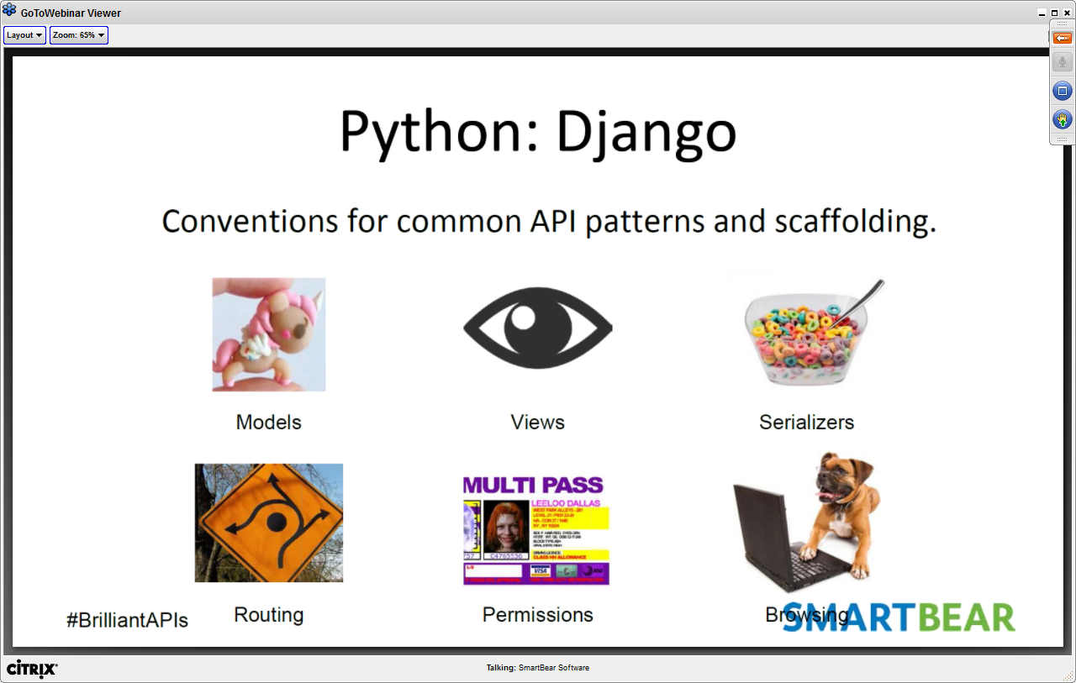

* Django is a fully featured app framework. Allows you to do
  + MVC and other API pieces
  + Models – data models
  + Views are a way to render the data (present them based on the client requirements). E.g. html for browser, css for someone else
  + Serializers are a way to represent data over wire (JSON/XML)
  + Routing essentially allows you to figure out how to route the requests coming in to the right process
  + Permissions – built in way for access control
  + Browseable APIs – built-in

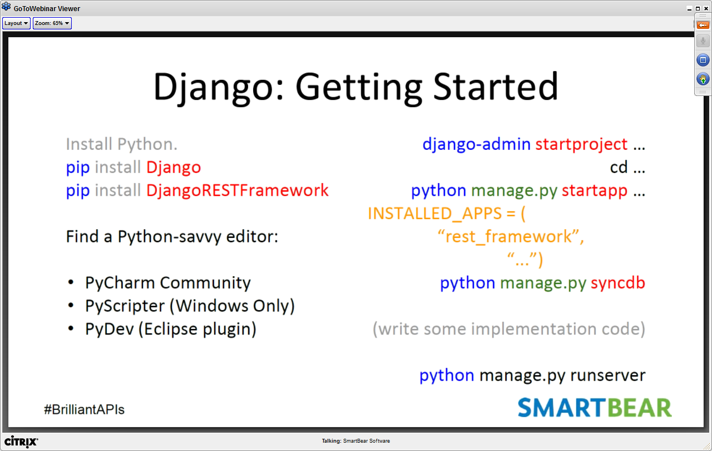

* Model
  + Book with chapters
  + Ability to connect up the cardinality

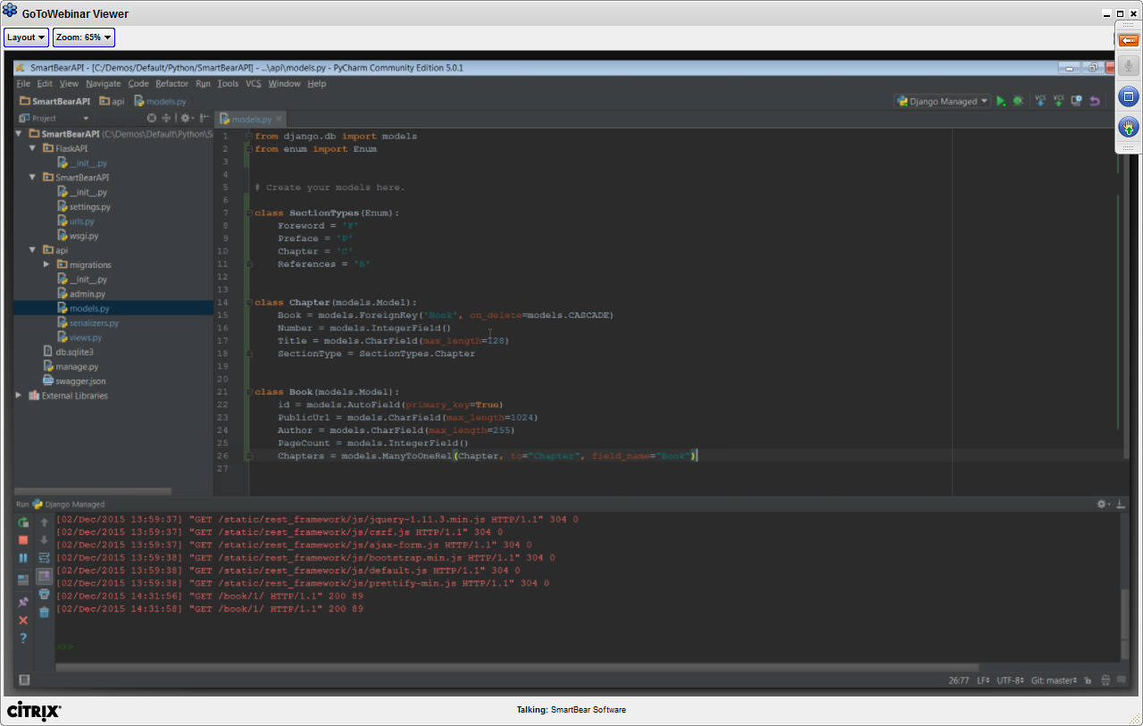

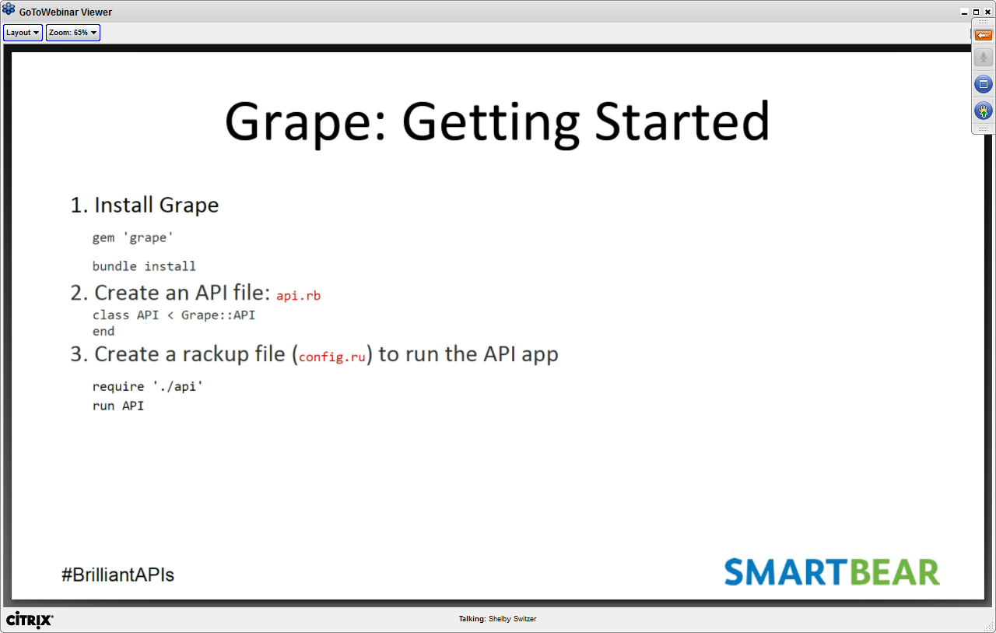

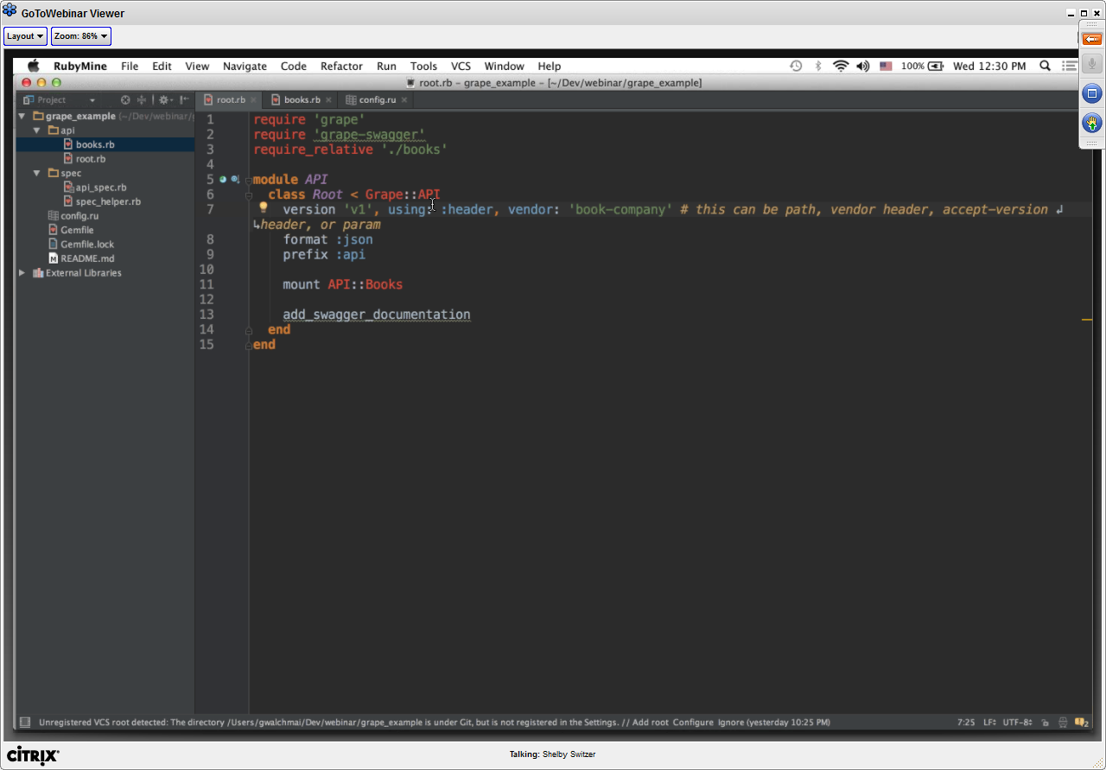

Books API

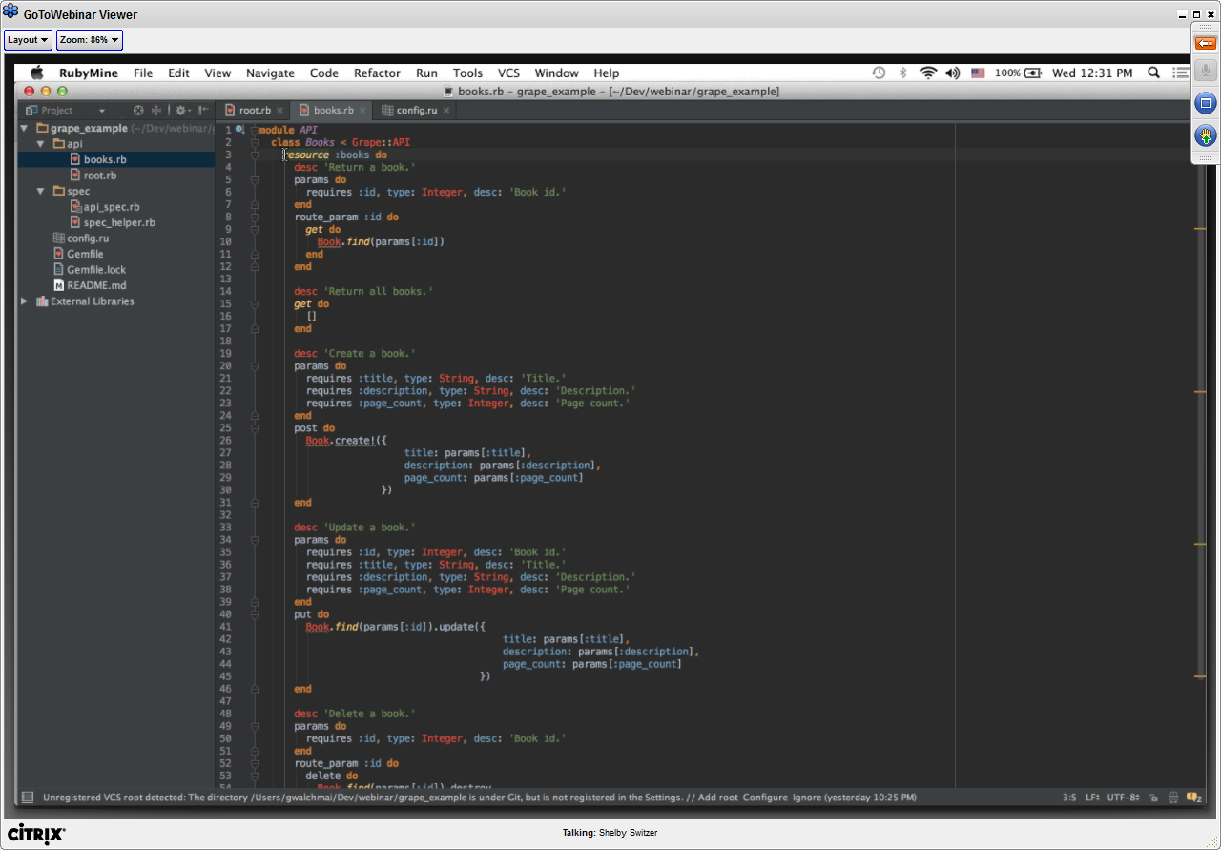

* Views

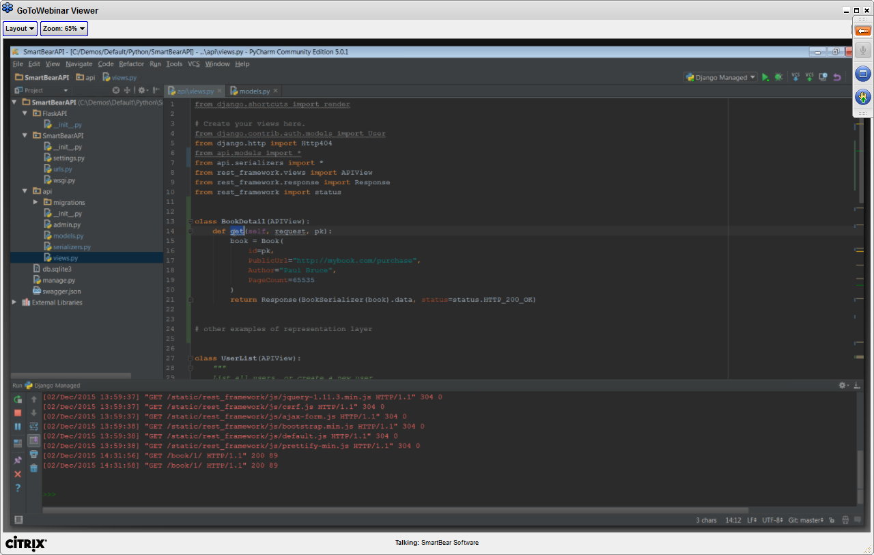

* Serializer

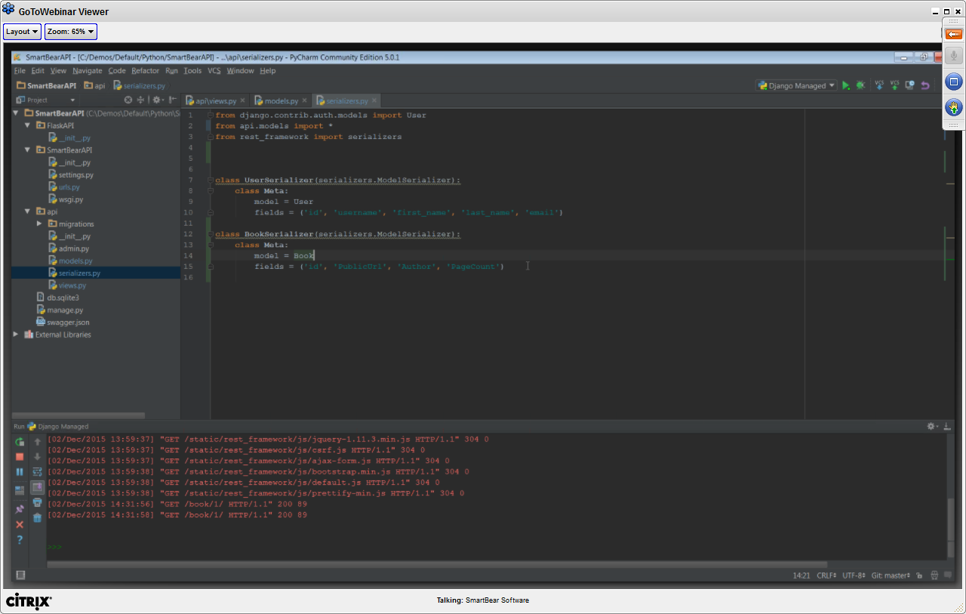

* Browsable API framework

